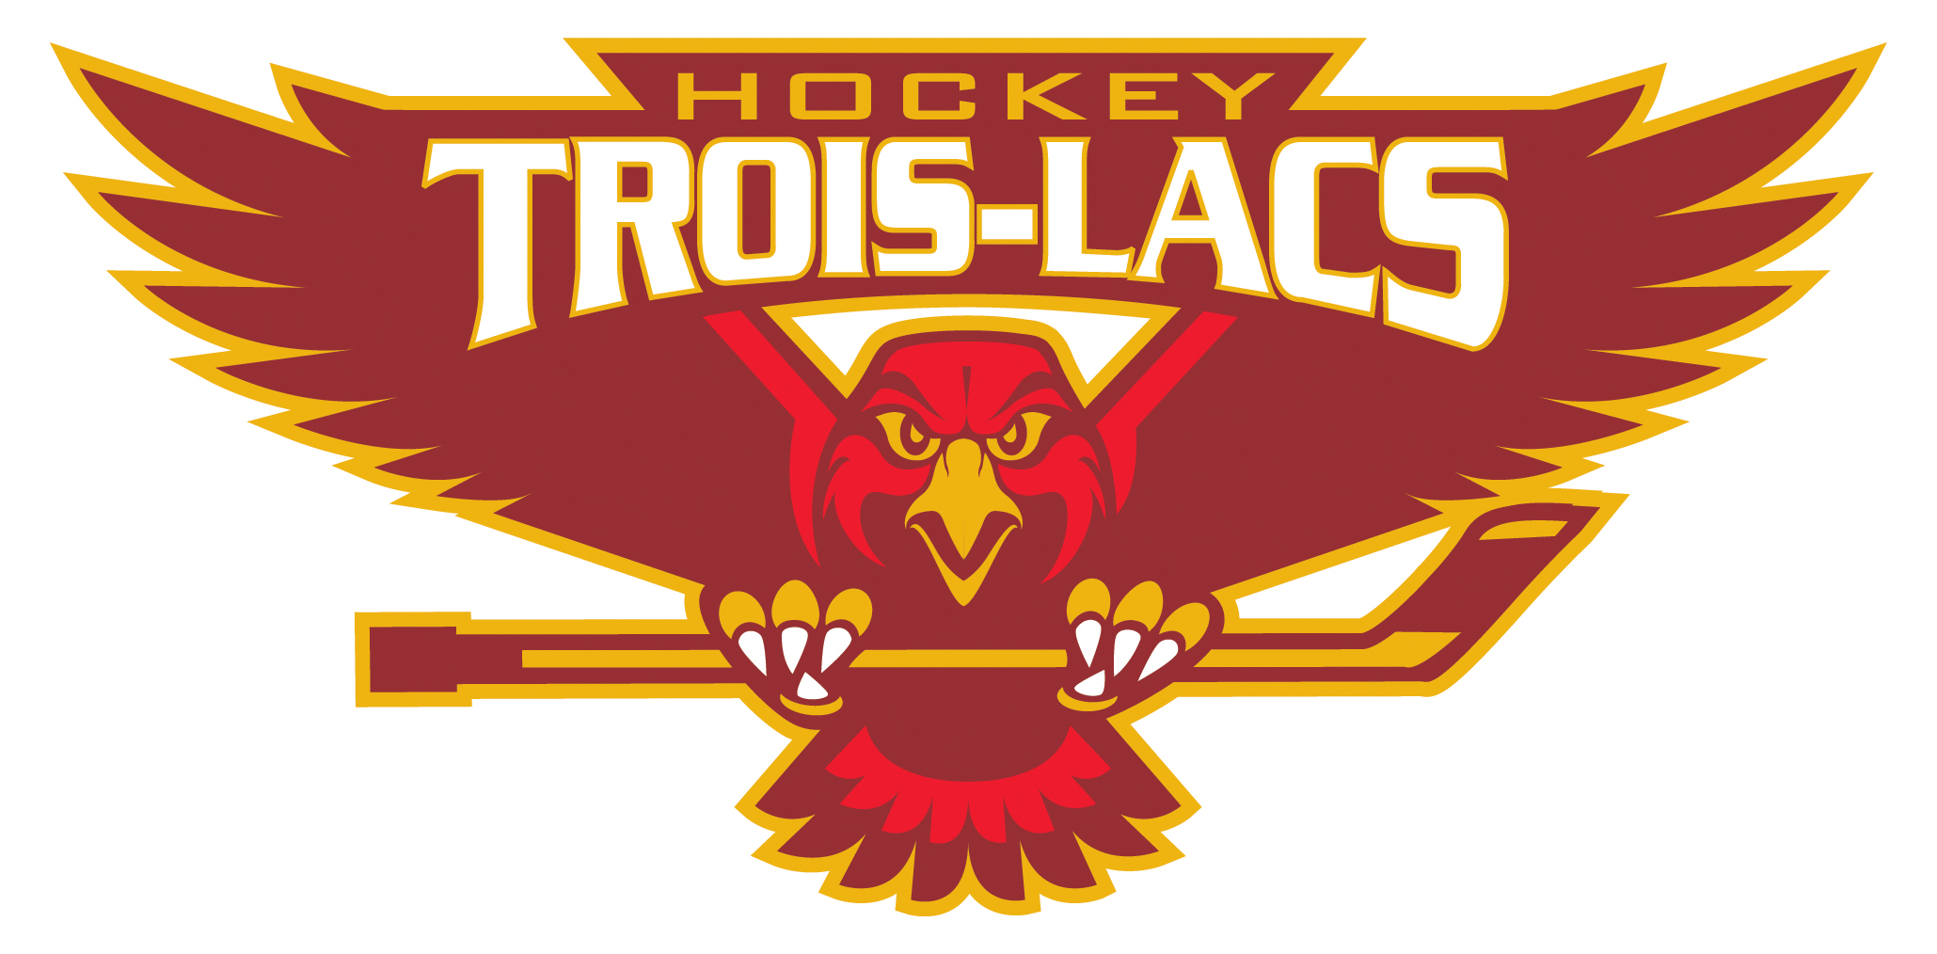
Selection Camps 2015-16 Hockey Trois-Lacs

Trois-Lacs Hockey selection camps will take place during a three week period from August 15th 2015 to September 4th 2015. Players will receive a minimum of 4.5 hours of ice per week. Cuts will be made after each week, hence players will have a minimum of two weeks in the camp.
Again this year, players will be evaluated by independent and professional evaluators.
From August 10th to August 14th there will also be « get back in shape » sessions which are not mandatory.

Cost for selection camps are as follows:

Get back in shape session (not mandatory): $15 per player
First two weeks of selection camp: $160 per player
Third week of selection camp: $80 per player

Payment information can be found on the camp registration form.
Players will receive a reversible jersey.

Categories:

Atom BB Atom CC
Pee Wee BB Pee WW CC
Bantam BB Bantam CC
Midget AA Midget BB

Don Simpson Sylvain Dugas Vezio Sacratini
President Governor Technical Director
Hockey Trois-Lacs Hockey Trois-Lacs Hockey Trois-Lacs

